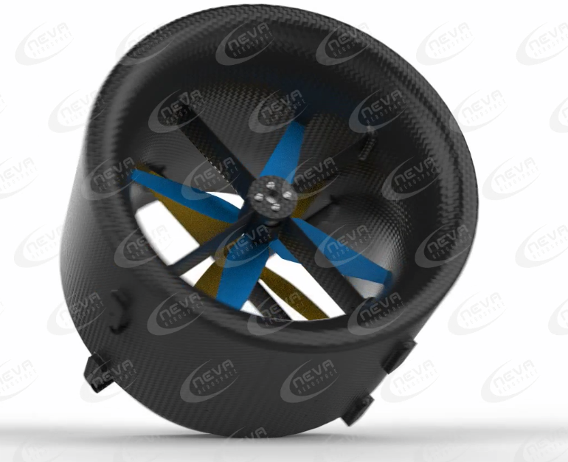

**User Manual  
Neva Athena-A-2ET-V1.xx**

**Document Ref.: NVA-UML-ATH-2ET-V1.XX-REV1.4**

Prepared by:

Neva Aerospace Ltd.  
  
Last Update: 10 April 2020  
  
www.neva-aero.com

DOCUMENT PREPARED AND APPROVED BY:

|  |  |  |
| --- | --- | --- |
| Internal document manager | - |  |
| Chief Science Officer | David Brotherton-Ratcliffe | Reviewed & Approved  10/04/2019 |
| Head of Engineering | Renaud-Pierre Blanpain | Reviewed & Approved:  04/04/2018 |
| Chief Executive Officer | Robert Florian Vergnes | Reviewed & Approved:  10/04/2019 |

Contents :

[2 Introduction 5](#_Toc28994888)

[3 Safety meaning of symbols 6](#_Toc28994889)

[4 Safety of Operations & Warnings 7](#_Toc28994890)

[5 Warranty, Limitations and Applications 9](#_Toc28994891)

[5.1 Warranty 9](#_Toc28994892)

[5.2 Limitations 9](#_Toc28994893)

[5.3 Applications 10](#_Toc28994894)

[6 Copyright and Patents: 11](#_Toc28994895)

[a. Copyright: 11](#_Toc28994896)

[b. Neva Aerospace Patents 11](#_Toc28994897)

[7 Product presentation 12](#_Toc28994898)

[7.1 Global view 12](#_Toc28994899)

[7.2 Summary Part List: 13](#_Toc28994900)

[7.3 Specifications: 15](#_Toc28994901)

[7.3.1 Units used: 15](#_Toc28994902)

[7.4 Temperatures: 16](#_Toc28994903)

[7.4.1 Operation Temperatures: 16](#_Toc28994904)

[7.4.2 Storage Temperature: 16](#_Toc28994905)

[7.5 Ingress Protection 16](#_Toc28994906)

[7.5.1 First Digit – Solid Particle Protection 16](#_Toc28994907)

[7.5.2 Second Digit – Liquid Ingress Protection 17](#_Toc28994908)

[7.6 Cleaning 17](#_Toc28994909)

[7.7 Efficiency Tables 18](#_Toc28994910)

[7.8 General drawing 20](#_Toc28994911)

[8 Mounting Athena to your Aircraft / UAV /UAS 22](#_Toc28994912)

[8.1 Before to mount to aircraft 22](#_Toc28994913)

[8.2 Mounting points (Holders) : 23](#_Toc28994914)

[9 Mounting to Aircraft /UAV /UAS 25](#_Toc28994915)

[10 Connecting Athena – Plug & Play 27](#_Toc28994916)

[a. Power 27](#_Toc28994917)

[b. Wiring 27](#_Toc28994918)

[10.1 CW and CCW: 29](#_Toc28994919)

[c. Running the Turbine for the First Time: 31](#_Toc28994920)

[11 Pre-flight Procedures: 33](#_Toc28994921)

[a. Pre-flight checks 33](#_Toc28994922)

[b. Pre-Take-off: 33](#_Toc28994923)

[11.1.1 1 - Extended Ground Run (EGR) Procedure 33](#_Toc28994924)

[11.1.2 2- Short Ground Run (SGR) Procedure 34](#_Toc28994925)

[Notes: 34](#_Toc28994926)

[12 Post-Flight Procedure – **After Each Landing** 34](#_Toc28994927)

[12.1 Cool-down procedure: 34](#_Toc28994928)

[13 Maintenance operations 35](#_Toc28994929)

[13.1 Marks and serial: 35](#_Toc28994930)

[13.2 Legal Maintenance 36](#_Toc28994931)

[13.3 Maintenance Schedule: 36](#_Toc28994932)

[13.3.1 Schedule of maintenance table 37](#_Toc28994933)

[13.3.2 Turbine Inspection – Max Flight Time without checks – 30HRS: 37](#_Toc28994934)

[13.3.3 Concentricity Screws: 38](#_Toc28994935)

[13.3.4 Athena-A-2ET-V1.65: (plastic composite) 40](#_Toc28994936)

[13.3.5 Pressure Equalisation 41](#_Toc28994937)

[13.3.6 Turbine Shroud Warranty 41](#_Toc28994938)

[13.3.7 Table of Spare Parts 41](#_Toc28994939)

[13.4 Electronic Speed Controller for the Motor(s) 43](#_Toc28994940)

[13.4.1 INTRODUCTION 44](#_Toc28994941)

[13.4.2 IMPORTANT WARNINGS 44](#_Toc28994942)

[13.4.3 CONNECT THE ESCS TO YOUR FLIGHT CONTROLLER 44](#_Toc28994943)

[13.4.4 FIRST-FLIGHT SETUP 45](#_Toc28994944)

[13.4.5 OPERATION 45](#_Toc28994945)

[13.4.6 PROGRAMMABLE FEATURES 45](#_Toc28994946)

[13.4.7 ESC OPERATIONAL TONES AND ERROR CODES 45](#_Toc28994947)

[14 Warranty & Legal 46](#_Toc28994948)

[14.1 Legal Maintenance 46](#_Toc28994949)

[14.2 Warranty Time: 46](#_Toc28994950)

[14.3 Timing the warranty and wear parts: 46](#_Toc28994951)

[14.4 Legal in case of reselling and second-hand equipment: 46](#_Toc28994952)

[14.4.1 Resell Process: 47](#_Toc28994953)

[14.4.2 Process for Transfer of Ownership: 47](#_Toc28994954)

[14.4.3 Failing to respect this procedure can lead to the following: 47](#_Toc28994955)

[14.4.4 Purchase of Second Hand Neva’s Equipment: 48](#_Toc28994956)

[14.4.5 Legal on Turbine reselling & ownership: 48](#_Toc28994957)

[14.4.6 Stolen or Lost Equipment: 48](#_Toc28994958)

[15 Legal disclaimer 49](#_Toc28994959)

[16 ANNEXES 50](#_Toc28994960)

[16.1 Neva End User Licence 50](#_Toc28994961)

# Introduction

Welcome to the Age of Electric Aviation! Neva Aerospace is pleased to sell, support and service the Athena series Electric turbine and greatly appreciates your purchase.

We hope Neva turbines bring you an enjoyable journey to VTOL, STOL and Electric aviation.

We use the words “turbine”, “turbofan”, “Electric Ducted Fan (EDF)”, and “Electric Turbofan (ETF)” interchangeably.

At Neva we prefer ETF or electric turbofan as our turbines are engineered differently to provide higher efficiency than standard EDFs.

The Neva Aerospace Athena Series are Electric Turbofans (ETFs) engineered for efficient Vertical Take-Off and Landing (VTOL).

These devices are known by various names worldwide: “Standschub optimimerter elektroimpeller” or “Elektro-turbo-fan” in Germany, “Turbine électrique de poussée statique” in France and “Electric VTOL Turbo-Fan (ETF)” or “static thrust Electric Ducted Fan (EDF)” in the UK and USA.

Neva Athena Series turbines are the result of several years of R&D and provide high performance and remarkable efficiency. In particular they are designed for static thrust and are optimised for VTOL and STOL operations.

Obviously, the use of electric turbines for aviation is a serious business. The Athena turbine has undergone extensive testing and evolution in order to ensure safety and reliability. Nevertheless, it is not a recommended power-plant for non-engineers or non-aero-technicians.

It requires a good background in aero-engineering, flying and a working understanding of the principles of turbine engines, along with a disciplined commitment to correct and safe operation, in accordance with these instructions.

To begin, read this manual thoroughly. Develop an overall impression of the turbine and its operating procedures, measuring equipment and accessories. Study the material step-by-step and ascertain how to install, operate and maintain your turbine engine. If you are unsure about anything, re-read it again.

DO NOT OPERATE THE Athena turbine BEFORE YOU HAVE READ THE MANUAL AND FULLY

UNDERSTAND EVERY PROCEDURAL DETAIL!

Should you still have doubts or questions, do not hesitate to contact Neva Aerospace for further assistance.

The Athena Series turbine closely functions like an electric ducted fan. You may have one or two stages compressing the incoming air. The inner body of the turbine (inner-shroud) and the blades have been designed and engineered to provide higher efficiency than a usual EDF.

All of our Athena Series turbines are powered by DC electricity and driven by an Electronic Speed Controller (ESC) which connects the source of electricity (batteries or power supply) to the motor(s). The ESC must also be connected to a flight controller or a PWM generator.

The Athena turbine series have one or two sophisticated on-board ESCs that controls and monitors each motor’s operating parameters. These parameters can be displayed if your turbine is connected to your flight controller and/or an on-board flight computer.

Each turbine is delivered with all components mounted required for proper operation and is a “plug and play” configuration.

# Safety meaning of symbols

|  |  |
| --- | --- |
| C:\Users\rober_000\AppData\Local\Microsoft\Windows\INetCache\Content.Word\Icon Warning Reactor.png | **WARNING TURBINE**  **ENSURE THAT you have a fully free volume of air in front of your turbine(s) during all operations.** |
| C:\Users\rober_000\AppData\Local\Microsoft\Windows\INetCache\Content.Word\Ne Pas Toucher.png | DANGEROUS AREA – DO NOT TOUCH  NEVER TOUCH INLET OR OUTLET OF THE TUBINE WHILE IN OPERATION.  TOUCHING INLET OR OUTLET OF THE TURBINE DURING OPERATION CAN LEAD TO SEVERE INJURIES. |
| Image associée | ATTENTION!  This symbol highlights the following points which must be strictly observed by the user! Any violation of the corresponding restrictions may impair the safe operation and the safety of the user. |
| Résultat de recherche d'images pour "fire danger" | ATTENTION!  Fire or explosion hazard! |
| Résultat de recherche d'images pour "ehs sign hot surface risk" | ATTENTION!  This symbol warns of hot objects and surfaces.  Any violation of the corresponding restrictions may affect the health of the user. |

# Safety of Operations & Warnings

|  |  |
| --- | --- |
| Image associée | **WARNING!**  **Errors and / or defects in the construction or operation of an Athena Turbine can lead to personal injury or even death**. |
| Image associée | **ATTENTION!**  **Before you put a UAV in operation, you must learn about the law. Legally, a UAV is subject to applicable laws which must be strictly adhered to. The rules of other countries are to be observed accordingly.** |
| Image associée | **WARNING! The maintenance and/or operation of the turbine under the influence of alcohol, drugs, medicines, etc. are strictly forbidden. These activities must take place only in the best physical and mental health condition. This applies to both the operator and any assistants.** |
| Image associée | **WARNING! The *Neva* turbines were designed exclusively for aircraft and are NOT suitable for any other purpose. Never use for any other purpose except for the flight of an aircraft. Any other types of uses may result in personal injury or death.** |
| Image associée | **WARNING! Any deviations from these instructions or the instructions of the manufacturer, the use of other parts or materials or changes to the system may have an adverse effect on the functionality and reliability of the turbines and therefore must be avoided at all costs.** |
| Image associée | **WARNING! The operation of an Athena turbine can only be done under strict accordance of the aircraft, remote control and turbine operation manual and applying local rules. Before flying, all control functions and surfaces as well as the range of the remote-control system must be checked according to manufacturer instructions. The checking of these operations must be repeated with a running turbine engine including the remote-control system range.** |
| Image associée | **WARNING! In case of a mishap, fire extinguishers should be on hand at all times. We recommend the CO2 variety.** |
| Image associée | **WARNING! When the turbine is running, never place your hands closer than 20 inches into the area of the intake. An extreme suction exists in this area; hands, fingers or other objects may be seized and ingested. Always be aware of this source of danger!**  **Prevent foreign materials from entering the intake or exhaust when working with the turbine. Before operation, make sure there are no lose parts or debris near the turbine. Objects being sucked in can cause severe damage.** |
|  | **WARNING! The overflight of people, especially at low altitude is regulated and Neva cannot be held responsible in case of a crash involving an aircraft where our turbines are mounted and people or other assets.** |
|  | **WARNING! To avoid hearing damage, always use hearing protection when you are near a running turbine engine!** |

# Warranty, Limitations and Applications

## Warranty

**Warranty will be voided** under any of the following conditions:

* Exposure to mechanical stress exceeding normal operation, including but not limited to: hard landing, belly landing, crash landing, collision, etc…
* Use of replacement parts not approved by Neva Aerospace
* Modification in a manner not approved by NEVA Aerospace
* Failure to follow NEVA Aerospace maintenance guidelines
* Flight envelope exceeding Neva Aerospace specifications
* Flight not in compliance with local regulations
* Flight without proper licence and/or authorisation
* Theft or transfer of ownership without declaration
* Tampering with any of the concentricity screws of the turbine
* Your organisation does not possess a valid End User Licence(EUL) from Neva Aerospace

*Read the chapter 12 – Warranty & Legal for further information.*

Neva Aerospace makes no warranty or representation regarding airworthiness, certification, or intended use. You use Neva Aerospace equipment fully at your own risks and Neva Aerospace decline any responsibility from using its equipment and/or the legality of using its equipment within the intended airspace.



## Limitations

Any infringement to anyone of these limitations will null and void our warranty and will allow Neva Aerospace to lay full responsibility to the End User in case of incident or accident.

***Any modification made to the ESC, motor, propellers, fan or shroud geometry, or over-clocking will void the warranty.***

***Icing condition: De-icing may not be fitted and our electric turbines are currently not acceptable for use in icing conditions.***

***Flight Level: Not allowed to fly above 3 281 ft (Feet) / 1000 M (Meter)***

***Restrictions:*** *Civilian applications, no warranty is provided for application more than 25kg MTOW aircraft (LT25) unless other written approval from Neva Aerospace.* ***Military applications are strictly prohibited unless you have a licence from neva Aerospace.***

**About Certifications & Flight Rules:**

*We make no warranties on the acceptability by the local regulator nor certification under local UAV/UAS regulation or Manned aircraft regulations. It is the full responsibility of the integrator, aircraft manufacturer, to liaise with its certification body.*

**Unmanned:**

*Our turbofans may be used for VLOS & RLOS up to 25Kg MTOW depending on your region and local laws; and may not be suitable for BVLOS or BRLOS according to your local rules.*

*Applications with a MTOW higher than 25kg and/or above 3300ft require a special authorisation from Neva Aerospace Ltd to extend our standard warranty.*

**Manned:**

Our turbofans have to be certified within your aircraft under ULM, UAS or UAV or Prototype certification rules with your aircraft.

Our turbine may be suitable only for VFR certification.

## Applications

Key features:

Safety is intrinsic in the design of all Neva ETFs, all propellers are contained into a shroud:

* Internal redundancy with 2 separate stages, 2 motors, and 2 ESCs (2ET-version)
* Reduced size
* High thrust density
* Greater efficiency (high power loading as measured in kg/kW)

Athena A (autonomous) is offered in several variants:

* 2ET: 2 stages counter-rotating - (CW) or counter-clockwise (CCW) (first stage)

Athena Series turbines are delivered fully assembled with Electronic Speed Controllers (ESC), motors and propellers.

Applications:

Typical usage for manned or unmanned aircraft:

* Bespoke applications for medium sized UAS/UAV
* Bespoke heavy-payload, high-safety UAV/UAA
* Extreme sports (para-glider, para-motor base-jump, Turbo-Ski, etc…)
* Security and defence applications
* Electric aviation: high efficiency VTOL and low speed linear flight
* Airships: high efficiency thrust for VTOL & low speed linear flight

# Copyright and Patents:

## Copyright:

All information in this Manual is proprietary to Neva Aerospace and/or Neva Aerospace Consortium Members and/or Neva Aerospace Technology Partners and/or Neva Aerospace Suppliers.

Copyright 2015, 2016, 2017, 2018.

**REPRODUCTION OR COPY IS PROHIBITED WITHOUT PRIOR APPROVAL.**

All images are non-contractual and may differ from original product manufactured and delivered to you.

## Neva Aerospace Patents

(EU, USA, and INTL) granted and/or pending:

Our work on electric turbines is patented:

USA: DM/089417, 9096314

EU: 2016-5567, GB2014/053724

Canada: PCT/GB2014/053724

Japan: DM/089417

UK : GB2529021, GB2014/053724, GB2468787

And

USA : 29538419, UD 053147-5

EU : 003427061-0001

France (EU Ext.) : EU-INPI-2016-5567

JAPAN (INT) : DM/089417

USA (INT) : DM/089417

EU (INT) : DM/089417

INT : DM/089417

France (EU ext.) : 2017-1406

France (EU ext.) : EU-INPI-2017-2802

This list is an extract of Neva Aerospace patents portfolio and we may have more unlisted due to running procedures. The list is not exhaustive.

**Any reverse engineering or copying is prohibited and will lead to legal inquiries and further actions.**

If you need support or replacement, please contact Neva’s support team: [support@neva-aero.Com](mailto:support@neva-aero.Com) .

# Product presentation

## Global view

Neva Aerospace Athena Series are Electric Ducted Fans (EDF) for Vertical Take-Off and Landing (VTOL). These are known by various names worldwide: *Standschub optimimerter Elektroimpeller or Elektro-Turbo-Fan* in Germany, *electric VTOL turbines* or *“Turbine électrique de poussée statique”* in France and *electric VTOL turbo-fans* in the USA.

Neva Athena Series are the result of several years of Research & Development and provide high performance and efficient electric ducted fans designed for static thrust and optimised for VTOL and STOL operations.

Safety is intrinsic in the design of all Neva EDFs as there are no uncaged propellers.

* Internal redundancy with 2 separate stages, 2 engines, and 2 ESCs (2ET)
* Intrinsic safety
* Reduced size
* Greater efficiency
* Athena Series have been designed for static thrust and are delivered fully assembled with Electronic Speed Controllers (ESC), motors and propellers.

Figure : Athena-A-2ET-V1.1 (2 stages contra-rotating)

* **Any change in the ESC, motor or propellers or over-clocking will void the warranty.**

## Summary Part List:

Athena Turbofan 2 stages components:

|  |  |
| --- | --- |
| Shroud  SHO3AXXX |  |
| Inlet stage  STR1AXXX |  |
| Outlet stage  STR2AXXX |  |
| Stator  STA3AXXX |  |
| Propellers (inlet and outlet)  PRO1AXXX and PRO2AXXX |  |
| Cap  CAP3AXXX |  |
| ESC  ESC3AXXX | http://www.castlecreations.com/img/product/010-0135-00_1-Z.jpg |
| Motor  MOT3AXXX |  |

The Athena Turbofan 2 stages is composed of (fig.2):

* + - Turbofan body (shroud)
    - Inlet stage
    - Outlet stage
    - Two (2) Electric Motors
    - Two(2) Electric Speed Controllers ESC

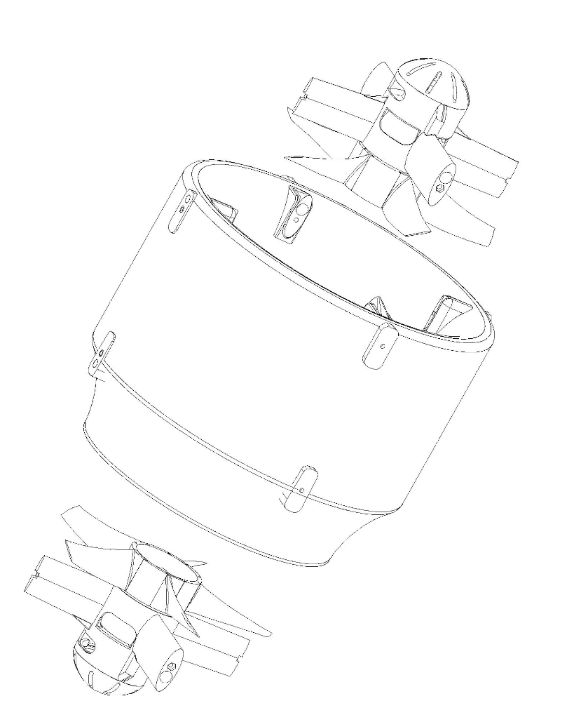Each stage contains propeller, motor and ESC.

Figure : Shroud, inlet and outlet stage

## Specifications:



*\*Measurements on Athena-A-2ET-V1.5x – Dec. 2016* ***|***  *\*\* Measurements on Athena-A-st-2ET-V1.5x Feb. 2017.*

*\*Measurements on Athena-A-2ET-V1.52 – Apr. 2017* ***|***  *\*\* Measurements on Athena-A-2ET-V1.60 Feb. 2017.*

*Notes:*

*1.5x and 1.6x are in different composite materials and so have different density and weight ratio.*

*1.5x shroud: carbon composite, and other parts: plastic composite.*

*1.6x shroud: plastic composite and other parts: plastic composite.*

### Units used:

*International System of Units (SI Metric): kg= kilogram, g=gram, W=Watt, kW=Kilo-Watt, N=Newton, kN= Kilo-Newton, C= Degree Celsius*

*Non-SI Units (European): kgf=kilogram force means thrust measured in kilograms; g/We (or gf/W) means efficiency in gram-force-thrust per Watt electric consumed*

*Non-SI Units (Imperial): lb=Pound-mass, lbf = pound-force, klbf= 1000-pounds-force (Kip-force) means thrust measured in thousand of pound; efficiency lbf/KWe = pound-force of thrust per Kilo-watt of electricity consumed.*

**Weight & Control Systems:**

*ESC means Electronic Speed Controller*

*The weight of our turbofans includes shroud, motors, propellers, and motor holder(s) but not the ESCs. ESCs are delivered by Neva Aerospace together with the turbofans.*

**Accuracies:**

*All figures are given with a +/- 5% accuracy.*

*All thrusts in gf or in kgf and efficiencies (power loadings) in gf/We or kgf/We represent gross values and are given with reference to the International Standard Atmosphere for dry air (ICAO 1964) and as such pertain to measurements at 15 degrees Celsius at 1013.25hPa and zero humidity.*

## Temperatures:

### Operation Temperatures:

*Operating temperatures: non-icing conditions only & avoid direct sunlight when not flying*



*For Carbon Shroud : From -10 Degree Celsius (non-icing) to +50 Degree Celsius*

*For Plastic Composite shroud: From 0 Degree Celsius (non-icing) to +40 Degree Celsius*

### https://warehouse.activecollab.com/api/v1/files/2018-04%2F92f2e3bb1d440d49ec6d158f02d263caf7004f187ee42429902fd57abb3983a2a5dbf1626d051c4a553333c94687398535773d9e8d3a23df899b21f0d6e06097.png/a6304a512ed67879d2b3722f5841367a/previewStorage Temperature:



***No direct sunlight when not flying – storage in the shadow***

*From +5 DegC to +35 Degree Celsius with* ***no direct sunlight***

## Ingress Protection

*Turbine Ingress Protection Code (IP):* ***IP 53***

### First Digit – Solid Particle Protection

|  |  |  |
| --- | --- | --- |
| **5** | Dust protected | Ingress of dust is not entirely prevented, but it must not enter in sufficient quantity to interfere with the satisfactory operation of the equipment. |

### Second Digit – Liquid Ingress Protection

|  |  |  |
| --- | --- | --- |
| **3** | Spraying water | Water falling as a spray at any angle up to 60° from the vertical shall have no harmful effect. |

### Dust and Sand Atmosphere Operation

*Please note that high level of dust or sand in atmosphere may wear blades or motor bearings more rapidly than usual. The Maintenance chart may have to be adapted to your region of operation.*

## Cleaning

**MOTOR disarmed / disengaged, power unplugged.**

After each flight and before storage, remove dust or water or mud with a soft micro-fibre tissue.

Clean the motor compartment with compressed air – gently through the vent.

BEWARE of your hands if the rotor starts auto-rotation due to compressed air.

Neva recommends the use of Compressed Gas Duster or “canned air”.

Avoid over pressure from industrial compressor.

Blades must be softly cleaned.

Remove any fibre that would remain and store in a cool place away from direct sunlight.

## Efficiency Tables

**Efficiency Thrust vs Power – Athena-A-2ET-V1.53 (4S)**

**Efficiency Thurst vs Power - Athena-A-2ET-V1.53 (4S)**

**4S Data**

**Watt elec.**

**Newton**

**N/Kwe**

**Kgf**

**Kgf/kWe**

**Lbf**

**Lbf/kWe**

9,6

1,29

134,67

0,13

13,73

0,29

30,27

33,6

3,22

95,75

0,33

9,76

0,72

21,53

70,4

5,53

78,50

0,56

8,00

1,24

17,65

126,4

8,19

64,80

0,84

6,61

1,84

14,57

193,6

11,05

57,09

1,13

5,82

2,48

12,83

288

14,21

49,34

1,45

5,03

3,19

11,09

432

18,21

42,15

1,86

4,30

4,09

9,48

548,8

20,77

37,85

2,12

3,86

4,67

8,51

675,2

23,98

35,52

2,45

3,62

5,39

7,98

**Efficiency Thrust vs Power – Athena-A-2ET-V1.53 (4S)**

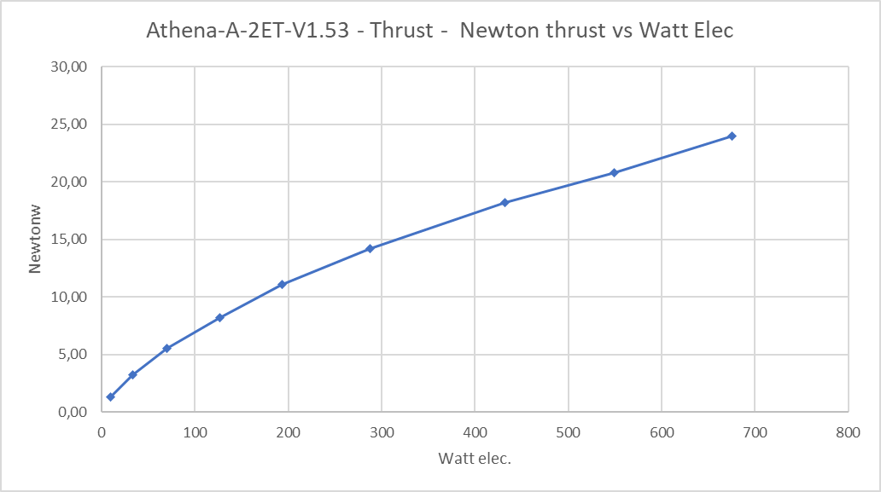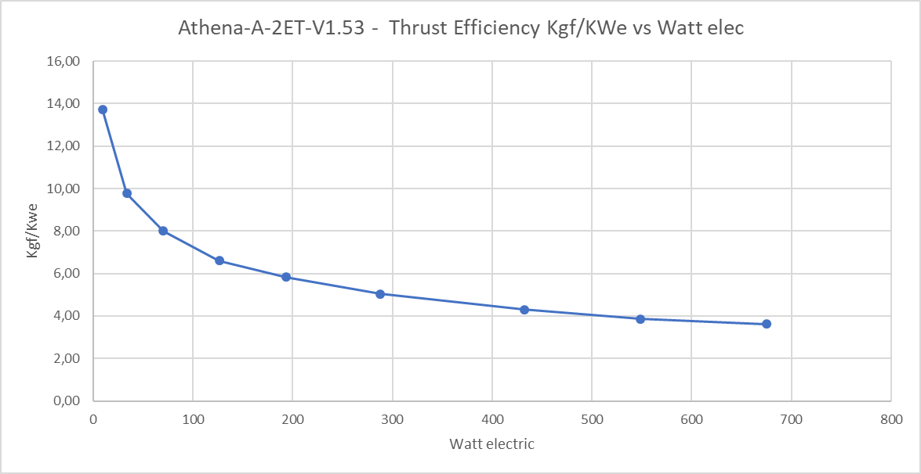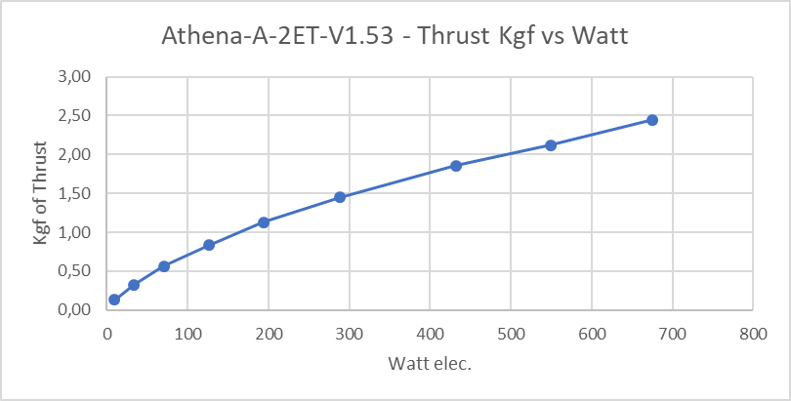

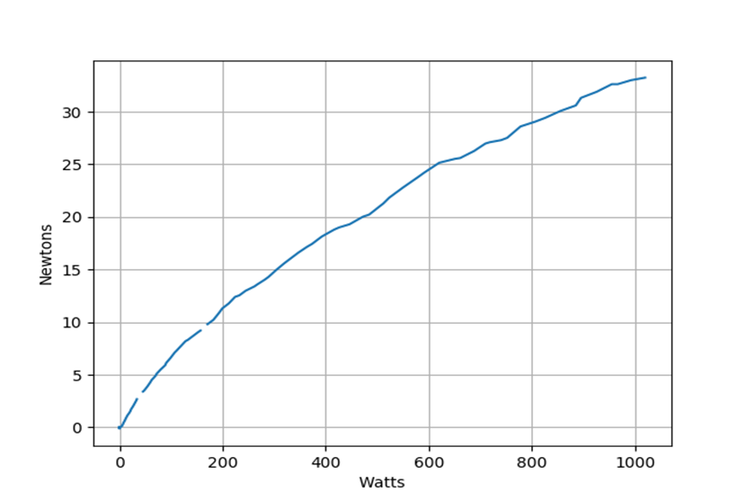

**Efficiency Thrust vs Power – Athena-A-2ET-1.64 (6S)**

**Technical Annex – Athena-A-2ET-V1.6x**

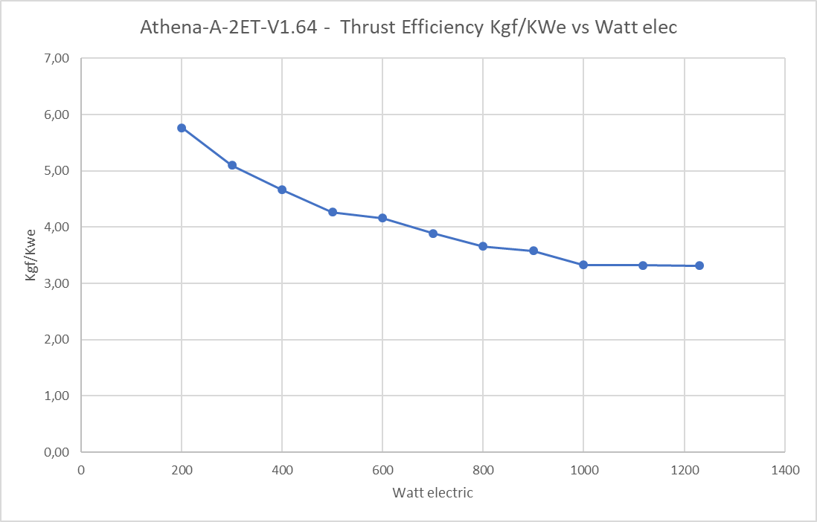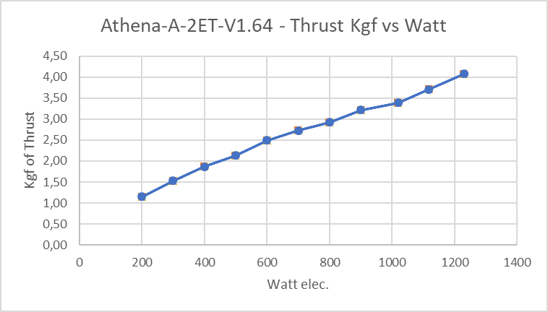

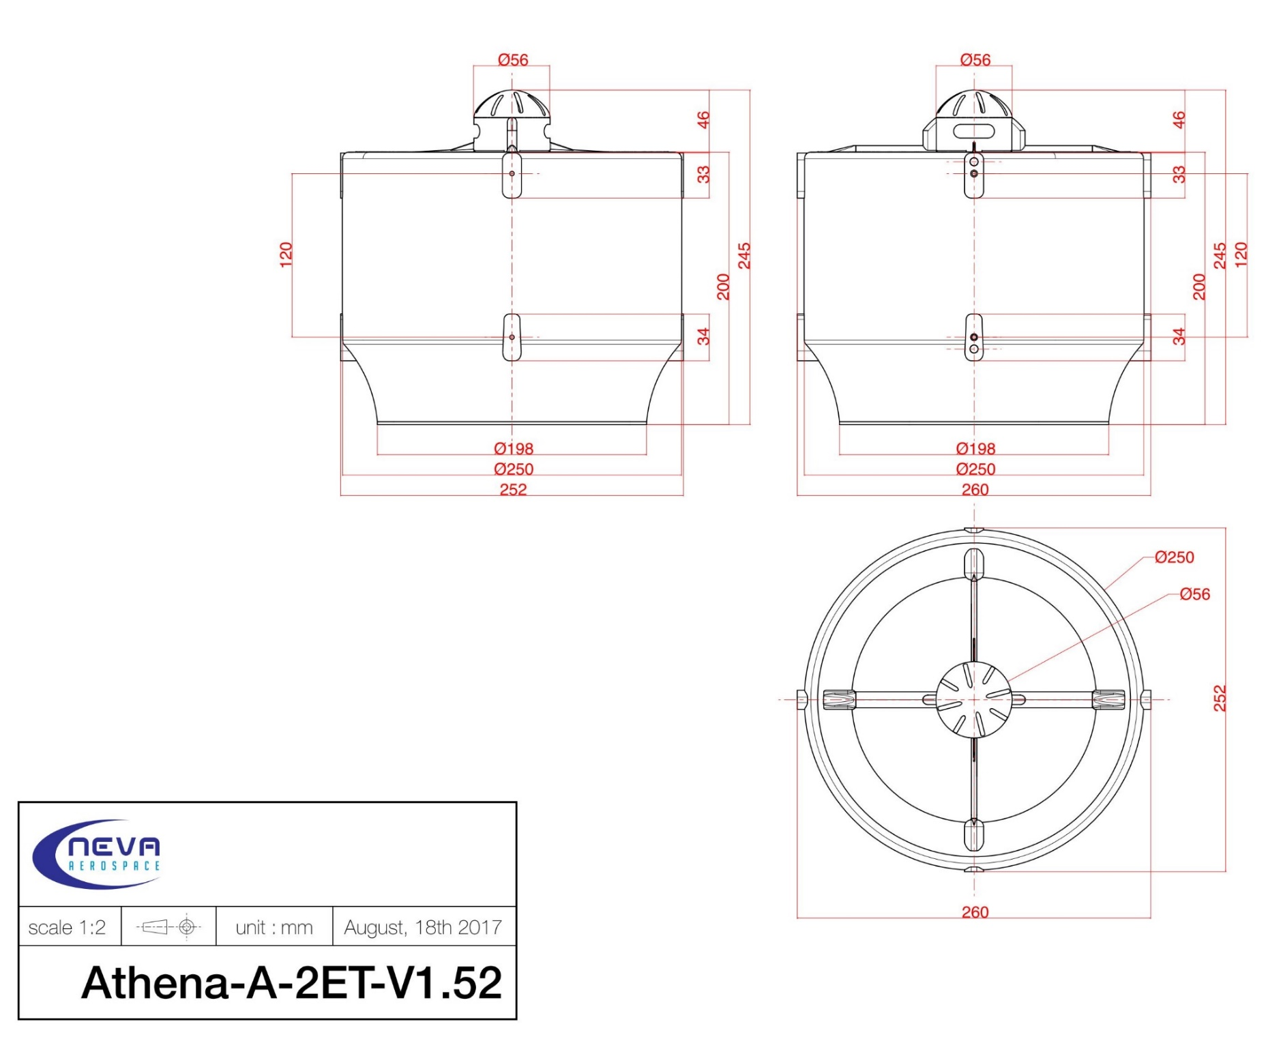

## General drawing

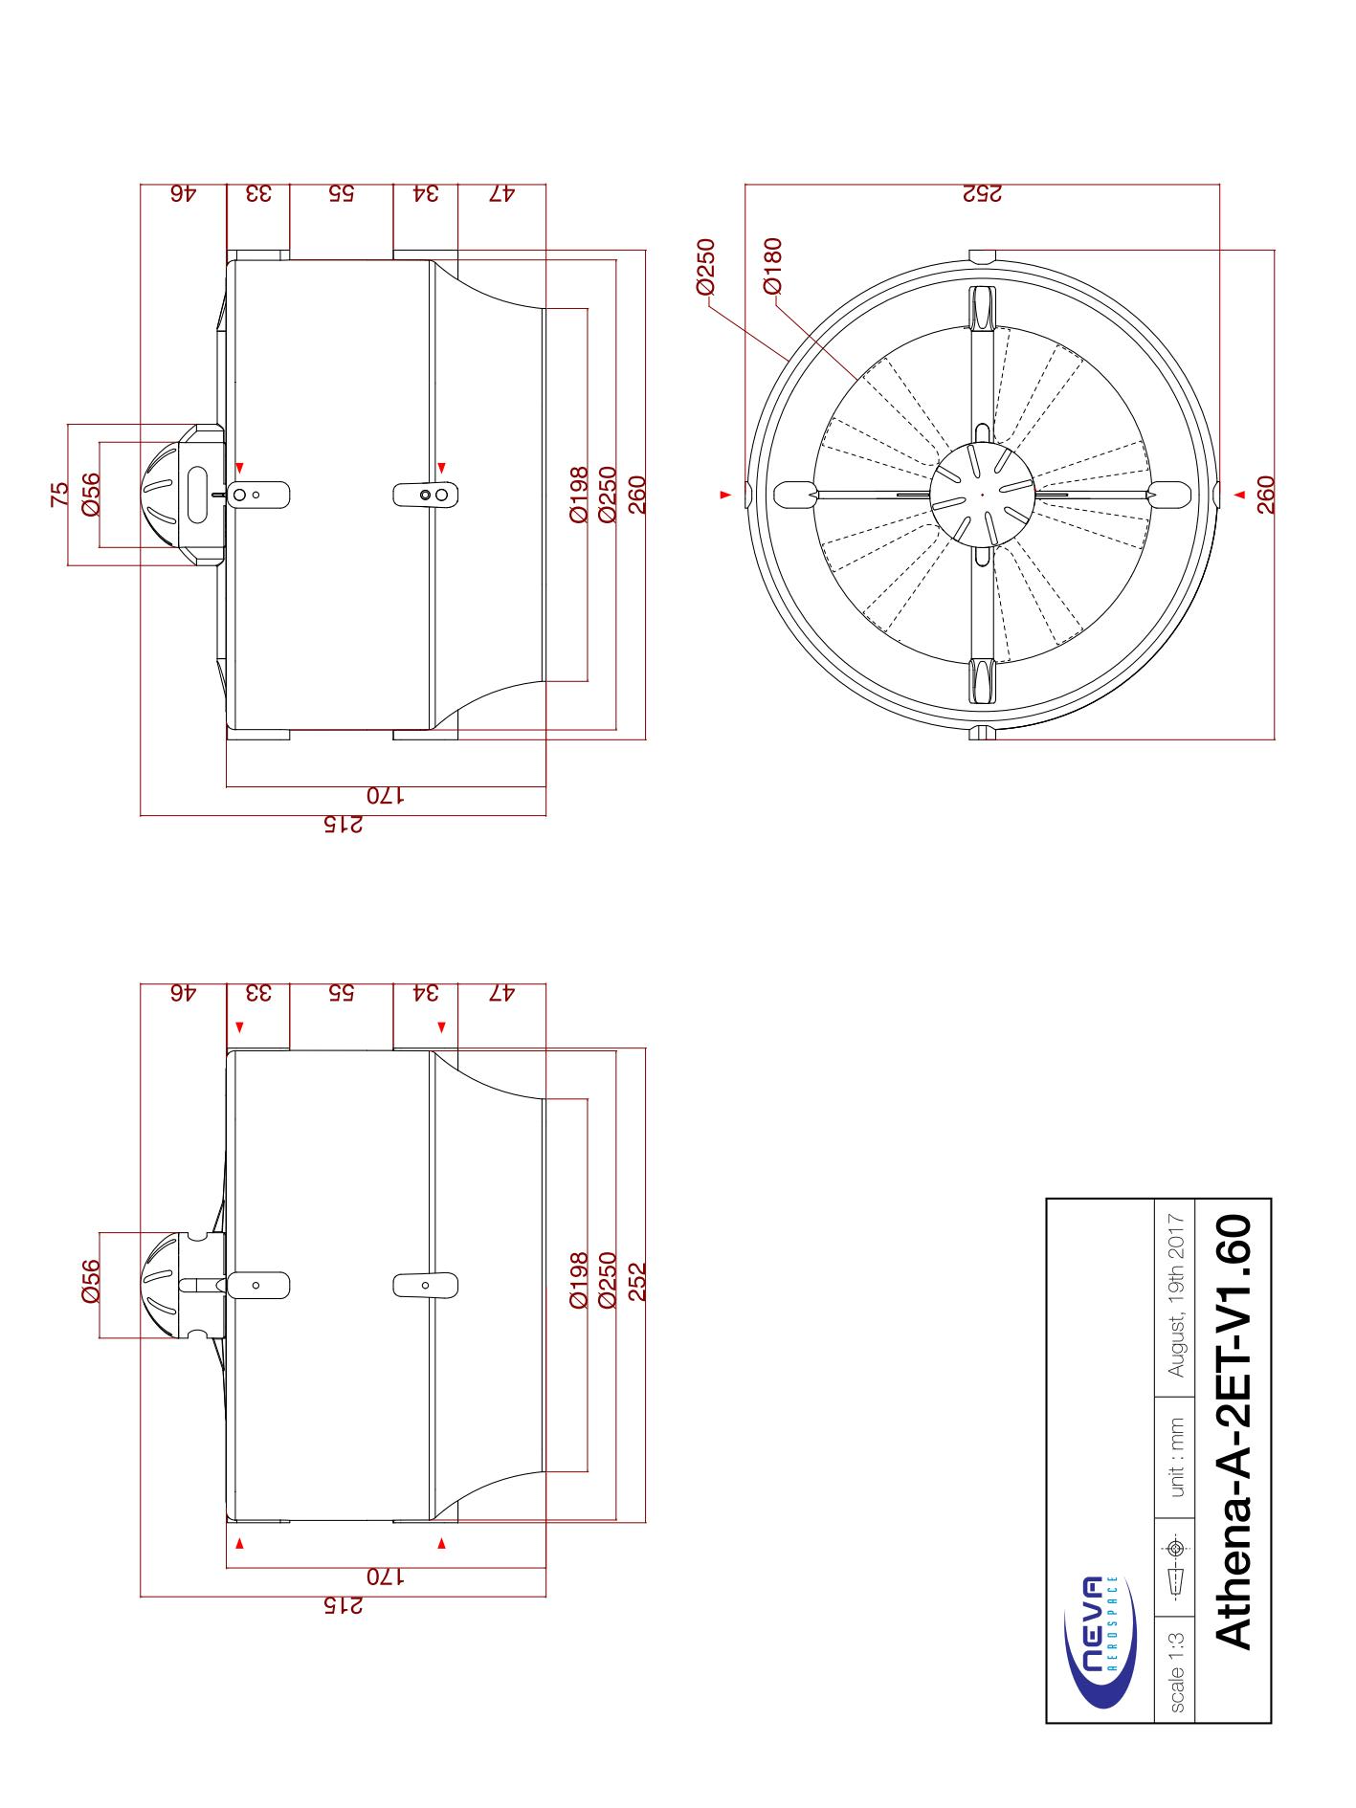

# Mounting Athena to your Aircraft / UAV /UAS

## Before to mount to aircraft

* Check that inlet and outlet stage are solidly connected to the turbine body (no movement possible)
* Check that each propeller turns freely without noise and without touching anything
* In any case NEVER PLUG the turbofan if it is not connected to an aircraft or a bench test. VERY SEVERE DAMAGE CAN RESULT FROM OPERATION OF A FREE TURBINE!
* Check that the location / volume where the turbine will be inserted /mounted respects the dimension of your specific turbine – see specification – [Chapter 7.7 – General Drawings](#_General_drawing)
* Ensure that the turbine exhaust is placed/mounted at least at 10cm from the ground or any wall. A turbine too close to the ground may lead to damage.

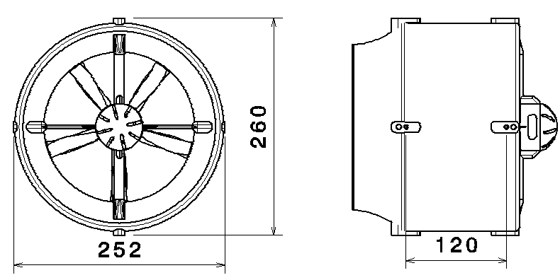

Figure : dimensions to respect, in mm (Athena-A-2ET-V1.52)

## Mounting points (Holders) :

And / Or



Figure 4: holder position

Your turbine can be mounted with one or two sides attached as shown here using the designated mounting points.

2 sides connection: Turbofan must be fixed on the both inlet and outlet stage on diametrically opposite sides using the connection plugs where the arms are the thickest (fig.4)

1 side connection: In case of single side attachment, the connection must also be on a thick arm’s side both outlet and inlet level.



Wider arm, wire outgoing side

Figure : example of a single side mount



Diametrically opposite arm

Wider arm, wire outgoing side

Figure : example of a double side mount

**Mounting bracket must be approved by Neva Aerospace if not provided by Neva Aerospace.**

[fig.6 – removed]

# Mounting to Aircraft /UAV /UAS

IT’S NOT POSSIBLE TO MOUNT THE TURBOFAN DIRECTLY TO AIRCRAFT/UAV/UAS

USE OF TURBINE HOLDER(S) IS MANDATORY

In the case you want to use your own designed brackets connection, please contact us.

* + - check the holder(s) on the turbofan is(are) correctly mounted, holder(s) and turbofan must be as a single parts (no movement possible between turbofan and holder(s))
    - Position the turbofan on its place
    - Fix the holder(s) on the structure - **use nylstop nut if any nuts are used, and threadlock on any mounting bolts**
    - Check that the turbofan can’t move by itself independently of the structure
    - Check by hand that both inlet and outlet propellers turn freely without any noise or resistance
    - Check that ESCs are in place, and:
      * That nothing obstructs the cooling vents of the ESC when embedded in the stator (arm holder of the motor hub)
      * That they can cool down correctly, if they are in a box, and/or outside of the turbine. In this case a cooling fan might be necessary.



Figure : DO NOT OBSTRUCT COOLING EVENTS

Cooling vents

# Connecting Athena – Plug & Play

## Power

The operating power for the turbofan is :

6-cell LiPo (6S LiPo) battery, for all 6S powered Turbine – Athena-A-2ET from V1.6.X

4-cell LiPo (4S Lipo) battery, for all 4S powered Turbine – Athena – A – 2ET from V1.3x to V1.5x

The battery plugs directly into the ESCs, which power on automatically. ESCs will beep intermittently if powered and receiver/flight controller is switched off.

If you plan to store the turbofan for more than a few weeks, the battery should be disconnected.

|  |  |
| --- | --- |
| Résultat de recherche d'images pour "fire danger" | **Attention! Fire!** A LiPo battery can explode if incorrect charge parameters are used. You should therefore always refer to the manufacturer's charger instructions. **NEVER** charge the batteries unattended. **Do not exceed the batteries maximum allowed charging current. READ AND OBEY WARNINGS ON BATTERY BEFORE CHARGING!** |
|  | Always ensure the batteries are at their optimal charge state before use. Please also note that at very low ambient temperatures, LiPo batteries have lower capacities. |

## Wiring

**Check propellers rotate freely before connecting anything**

* Connect inlet ESC RC plug to flight controller (“I” plug) and then outlet ESC RC plug (“O” plug) to flight controller in the case where the stages are managed separately (cf. fig.8)
* Connect the ESCs RC plug (“E” plug) to flight controller in the case where both stages are managed together (cf.fig.9)
* Connect the ESCs power plug/wires to battery or power supply. Wire guidelines:
  + Both ESCs powered over single wire pair: minimum wire cross-sectional area of 4mm² for a wire length of 1 meter maximum
  + Each ESC powered with separate wire pair: minimum wire cross-sectional area of 2.5 mm² for a wire length of 1 meter maximum

*Note:*

* The longer the power wire the higher the resistance and therefore the higher the power loss and overheating risk
* The longer the power wire, the thicker it must be
* We strongly recommend as short a power wire as possible

To Flight Controller

**To Flight Controller**

*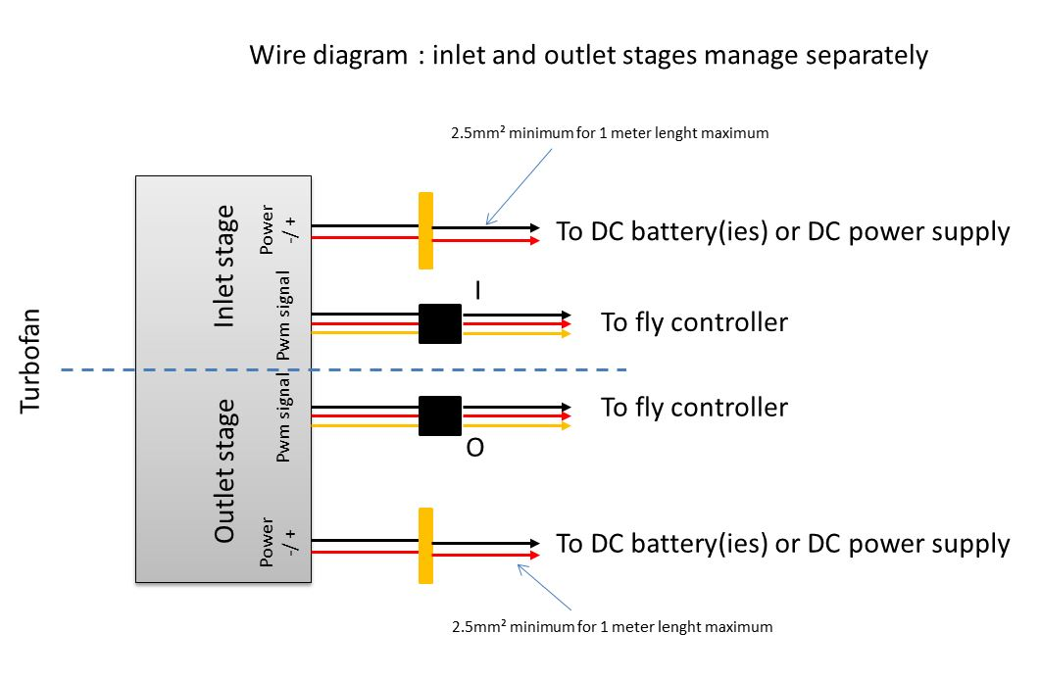*

Wire Diagram: Inlet and outlet stages managed separately

Figure : Turbofan connection, stages separated

*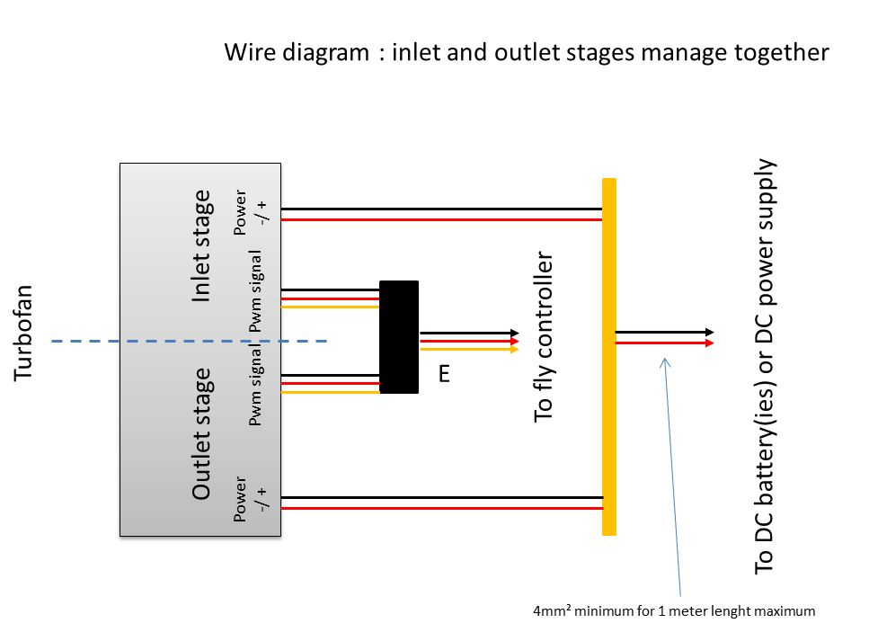*

Figure : Turbofan connection, stages together

## CW and CCW:

For 2 stage turbines (2ET), the standard terminology for turbine handedness is as follows: a **CW** turbine is one where, as viewed from the front, the **inlet** rotates **C**lock**W**ise (and the outlet counter-clockwise), and a **CCW** turbine means that the **inlet** is **C**ounter**C**lock**W**ise (and the outlet clockwise).

Due to flight controller command algorithms you may be required to mount certain turbines as CW and others as CCW (ie reverse inlet/outlet rotating sense)

How to be sure about CW and CCW turbofan :

* Check the marks on the shroud, CW means Inlet CW/Outlet CCW, CCW means the opposite
* With the turbine disconnected, visually check the rotation the inlet propeller should have
* By convention, **even** serial numbers are CW and **odd** serial numbers are CCW (fig.10)

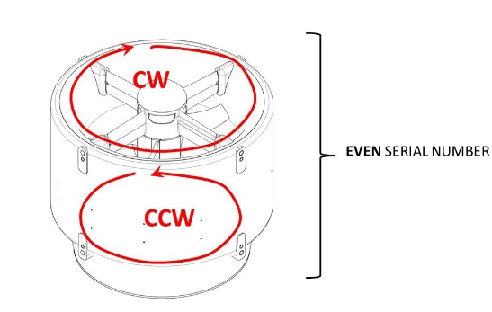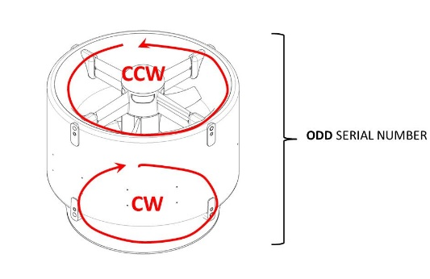

CCW Turbine

CW Turbine

Figure : CW or CCW in function of serial number

To know if your turbine is CW (Inlet CW and Outlet CCW) or CCW (Inlet CCW, outlet CW), then look at the serial number:

EVEN SERIAL NUMBER MEANS : CW Turbine (Inlet CW, outlet CCW)

ODD SERIAL NUMBER MEANS: CCW Turbine (inlet CCW, outlet VW)

## Running the Turbine for the First Time:

**Procedures:**

(!) WHILE PERFORMING TURBINE TEST YOUR AIRCRAFT OR BENCH TEST MUST BE SOLIDLY ATTACHED TO THE GROUND AND/OR TO A WALL!

* 1. Run the inlet and only the inlet slowly from 0% (pwm 1150µs) to 10% (pwm 1224µs) of the pwm signal, stabilize for 5 seconds, check that there is no suspect sound like knock or friction, stop immediately if there is, back to 0%
  2. Run the inlet and only the inlet slowly from 0% (pwm 1150µs) to 100% (pwm 1890µs) of the pwm signal in 10 seconds, stabilize for 5 seconds, check there is no suspect noise, decrease from 100% to 0% in 3 seconds
  3. Run the outlet and only the outlet slowly from 0% (pwm 1150µs) to 10% (pwm 1224µs) of the pwm signal, stabilize for 5 seconds, check that there is no suspect sound like knock or friction, stop immediately if there is, back to 0%
  4. Run the outlet and only the outlet slowly from 0% (pwm 1150µs) to 100% (pwm 1890µs) of the pwm signal in 10 seconds, stabilize for 5 seconds, check there is no suspect noise, decrease from 100% to 0% in 3 seconds
  5. Run both inlet and outlet slowly from 0% to 10% of the pwm signal, stabilizer for 5 seconds, check everything is ok (no knock, friction or suspect noise), back to 0%
  6. Run both inlet and outlet slowly from 0% to 100% of the pwm signal in 10 seconds, stabilized for 5 seconds, check everything is ok (no knock, friction or suspect noise), decrease from 100% to 0% of the pwm signal in 3 seconds

|  |  |  |  |  |  |  |  |  |  |  |  |  |  |  |  |  |  |  |  |  |  |  |  |  |  |  |  |  |
| --- | --- | --- | --- | --- | --- | --- | --- | --- | --- | --- | --- | --- | --- | --- | --- | --- | --- | --- | --- | --- | --- | --- | --- | --- | --- | --- | --- | --- |
| **Inlet check - 1) and 2)** | | | |  |  |  |  |  |  |  |  |  |  |  |  |  |  |  |  |  |  |  |  |  |  |  |  |  |
|  |  |  |  |  |  |  |  |  |  |  |  |  |  |  |  |  |  |  |  |  |  |  |  |  |  |  |  |  |
| time / s | cumulative | 0 | 1 | 2 | 3 | 4 | 5 | 6 | 7 | 8 | 9 | 10 | 11 | 12 | 13 | 14 | 15 | 16 | 17 | 18 | 19 | 20 | 21 | 22 | 23 | 24 | 25 |  |
| relative | 0 | 1 | 2 | 3 | 4 | 5 | 0 | 1 | 2 | 3 | 4 | 5 | 6 | 7 | 8 | 9 | 10 | 1 | 2 | 3 | 4 | 5 | 1 | 2 | 3 | 0 |  |
| Inlet Signal µs | | 1150 | 1224 | 1224 | 1224 | 1224 | 1224 | 1150 | 1224 | 1298 | 1372 | 1446 | 1520 | 1594 | 1668 | 1742 | 1816 | 1890 | 1890 | 1890 | 1890 | 1890 | 1890 | 1644 | 1398 | 1150 | 1150 |  |
| OutletSignal µs | | 1150 | 1150 | 1150 | 1150 | 1150 | 1150 | 1150 | 1150 | 1150 | 1150 | 1150 | 1150 | 1150 | 1150 | 1150 | 1150 | 1150 | 1150 | 1150 | 1150 | 1150 | 1150 | 1150 | 1150 | 1150 | 1150 |  |
|  |  |  |  |  |  |  |  |  |  |  |  |  |  |  |  |  |  |  |  |  |  |  |  |  |  |  |  |  |
| **Outlet check - 3) and 4)** | | | |  |  |  |  |  |  |  |  |  |  |  |  |  |  |  |  |  |  |  |  |  |  |  |  |  |
|  |  |  |  |  |  |  |  |  |  |  |  |  |  |  |  |  |  |  |  |  |  |  |  |  |  |  |  |  |
| time / s | cumulative | 0 | 1 | 2 | 3 | 4 | 5 | 6 | 7 | 8 | 9 | 10 | 11 | 12 | 13 | 14 | 15 | 16 | 17 | 18 | 19 | 20 | 21 | 22 | 23 | 24 | 25 |  |
| relative | 0 | 1 | 2 | 3 | 4 | 5 | 0 | 1 | 2 | 3 | 4 | 5 | 6 | 7 | 8 | 9 | 10 | 1 | 2 | 3 | 4 | 5 | 1 | 2 | 3 | 0 |  |
| Inlet Signal µs | | 1150 | 1150 | 1150 | 1150 | 1150 | 1150 | 1150 | 1150 | 1150 | 1150 | 1150 | 1150 | 1150 | 1150 | 1150 | 1150 | 1150 | 1150 | 1150 | 1150 | 1150 | 1150 | 1150 | 1150 | 1150 | 1150 |  |
| OutletSignal µs | | 1150 | 1224 | 1224 | 1224 | 1224 | 1224 | 1150 | 1224 | 1298 | 1372 | 1446 | 1520 | 1594 | 1668 | 1742 | 1816 | 1890 | 1890 | 1890 | 1890 | 1890 | 1890 | 1644 | 1398 | 1150 | 1150 |  |
|  |  |  |  |  |  |  |  |  |  |  |  |  |  |  |  |  |  |  |  |  |  |  |  |  |  |  |  |  |
| **Both stage check - 5) and 6)** | | | | |  |  |  |  |  |  |  |  |  |  |  |  |  |  |  |  |  |  |  |  |  |  |  |  |
|  |  |  |  |  |  |  |  |  |  |  |  |  |  |  |  |  |  |  |  |  |  |  |  |  |  |  |  |  |
| time / s | cumulative | 0 | 1 | 2 | 3 | 4 | 5 | 6 | 7 | 8 | 9 | 10 | 11 | 12 | 13 | 14 | 15 | 16 | 17 | 18 | 19 | 20 | 21 | 22 | 23 | 24 | 25 | 26 |
| relative | 0 | 1 | 2 | 3 | 4 | 5 | 0 | 0 | 1 | 2 | 3 | 4 | 5 | 6 | 7 | 8 | 9 | 10 | 1 | 2 | 3 | 4 | 5 | 1 | 2 | 3 | 0 |
| Inlet Signal µs | | 1150 | 1224 | 1224 | 1224 | 1224 | 1224 | 1150 | 1150 | 1224 | 1298 | 1372 | 1446 | 1520 | 1594 | 1668 | 1742 | 1816 | 1890 | 1890 | 1890 | 1890 | 1890 | 1890 | 1644 | 1398 | 1150 | 1150 |
| OutletSignal µs | | 1150 | 1224 | 1224 | 1224 | 1224 | 1224 | 1150 | 1150 | 1224 | 1298 | 1372 | 1446 | 1520 | 1594 | 1668 | 1742 | 1816 | 1890 | 1890 | 1890 | 1890 | 1890 | 1890 | 1644 | 1398 | 1150 | 1150 |

Figure 10 : table time / signal for check procedure

# Pre-flight Procedures:

## Pre-flight checks

To do before any take-off

* + 1. Visual check: no foreign bodies inside the turbine
    2. Check that turbine are solidly connected to aircraft
    3. **Without power**: check that all propellers turn freely

## Pre-Take-off:

### 1 - Extended Ground Run (EGR) Procedure

(extended run-up)

**Procedure to run at least once per day of flying and/or each time there is a mounting modification for each turbofan:**

 (!) WHILE PERFORMING TURBINE TEST YOUR AIRCRAFT OR BENCH TEST MUST BE SOLIDELY ATTACHED TO THE GROUND AND/OR TO A WALL!

For each turbine on your aircraft:

* + 1. Inlet check Noise (only inlet) : 0% to 10% in 1s and back to 0% : no suspect noise, then 0% to 100% in 10s and back to 0% in 3 seconds, no suspect noise
    2. Outlet check Noise (only outlet) : 0% to 10% in 1s and back to 0% : no suspect noise, then 0% to 100% in 10s and back to 0%, no suspect noise
    3. Both inlet and outlet check Noise : 0% to 10% in 1s and back to 0% : no suspect noise, then 0% to 100% in 10s and back to 0% in 3 seconds, no suspect noise

|  |  |  |  |  |  |  |  |  |  |  |  |  |  |  |  |  |  |
| --- | --- | --- | --- | --- | --- | --- | --- | --- | --- | --- | --- | --- | --- | --- | --- | --- | --- |
| **Inlet check - 1)** | | |  |  |  |  |  |  |  |  |  |  |  |  |  |  |  |
|  |  |  |  |  |  |  |  |  |  |  |  |  |  |  |  |  |  |
| time / s | cumulative | 0 | 1 | 2 | 3 | 4 | 5 | 6 | 7 | 8 | 9 | 10 | 11 | 12 | 13 | 14 | 15 |
| relative | 0 | 1 | 0 | 1 | 2 | 3 | 4 | 5 | 6 | 7 | 8 | 9 | 10 | 1 | 2 | 3 |
| Inlet Signal µs | | 1150 | 1224 | 1150 | 1224 | 1298 | 1372 | 1446 | 1520 | 1594 | 1668 | 1742 | 1816 | 1890 | 1644 | 1398 | 1150 |
| OutletSignal µs | | 1150 | 1150 | 1150 | 1150 | 1150 | 1150 | 1150 | 1150 | 1150 | 1150 | 1150 | 1150 | 1150 | 1150 | 1150 | 1150 |
|  |  |  |  |  |  |  |  |  |  |  |  |  |  |  |  |  |  |
| **Outlet check - 2)** | | |  |  |  |  |  |  |  |  |  |  |  |  |  |  |  |
|  |  |  |  |  |  |  |  |  |  |  |  |  |  |  |  |  |  |
| time / s | cumulative | 0 | 1 | 2 | 3 | 4 | 5 | 6 | 7 | 8 | 9 | 10 | 11 | 12 | 13 | 14 | 15 |
| relative | 0 | 1 | 0 | 1 | 2 | 3 | 4 | 5 | 6 | 7 | 8 | 9 | 10 | 1 | 2 | 3 |
| Inlet Signal µs | | 1150 | 1150 | 1150 | 1150 | 1150 | 1150 | 1150 | 1150 | 1150 | 1150 | 1150 | 1150 | 1150 | 1150 | 1150 | 1150 |
| OutletSignal µs | | 1150 | 1224 | 1150 | 1224 | 1298 | 1372 | 1446 | 1520 | 1594 | 1668 | 1742 | 1816 | 1890 | 1644 | 1398 | 1150 |
|  |  |  |  |  |  |  |  |  |  |  |  |  |  |  |  |  |  |
| **Both Inlet & Outlet check - 3)** | | |  |  |  |  |  |  |  |  |  |  |  |  |  |  |  |
|  |  |  |  |  |  |  |  |  |  |  |  |  |  |  |  |  |  |
| time / s | cumulative | 0 | 1 | 2 | 3 | 4 | 5 | 6 | 7 | 8 | 9 | 10 | 11 | 12 | 13 | 14 | 15 |
| relative | 0 | 1 | 0 | 1 | 2 | 3 | 4 | 5 | 6 | 7 | 8 | 9 | 10 | 1 | 2 | 3 |
| Inlet Signal µs | | 1150 | 1224 | 1150 | 1224 | 1298 | 1372 | 1446 | 1520 | 1594 | 1668 | 1742 | 1816 | 1890 | 1644 | 1398 | 1150 |
| OutletSignal µs | | 1150 | 1224 | 1150 | 1224 | 1298 | 1372 | 1446 | 1520 | 1594 | 1668 | 1742 | 1816 | 1890 | 1644 | 1398 | 1150 |

Figure : table time/signal for EGR check

### 2- Short Ground Run (SGR) Procedure

(short run-up)

**To do before any take-off**

* both inlet and outlet : from 0% to 100% and back to 0% in 6 seconds (3s+3s)

|  |  |  |  |  |  |  |  |  |
| --- | --- | --- | --- | --- | --- | --- | --- | --- |
| **SGR check FOR EACH TURBINE :** | | | | | |  |  |  |
|  |  |  |  |  |  |  |  |  |
| time / s | cumulative | 0 | 1 | 2 | 3 | 4 | 5 | 6 |
| relative | 0 | 1 | 2 | 3 | 1 | 2 | 3 |
| Inlet Signal µs | | 1150 | 1397 | 1643 | 1890 | 1643 | 1397 | 1150 |
| OutletSignal µs | | 1150 | 1397 | 1643 | 1890 | 1643 | 1397 | 1150 |

Figure : table time/signal for SGR check

## Notes:

* If your aircraft is equipped with many turbines, ensure that there is a sequence to check all turbines one by one per the SGR Procedure before take-off- either manually or automatically.
* We suggest you log your EGR and your SGR – either manually or automatically

Check the noise and stop if anything unusual.

# Post-Flight Procedure – **After Each Landing**



**NEVER STOP A NEVA ELECTRIC TURBOFAN AFTER A FLIGHT WITH A STRAIGHT SHUTDOWN.**

**SHUTDOWN STRAIGHT AFTER A FLIGHT CAN HIGHLY DAMAGE MOTORS AND ESCs.**

**MOTOR AND ESC MUST COOL DOWN AFTER FLIGHT.**

## Cool-down procedure:



* **Run both stages of your Neva electric turbofan for at least 120 seconds (2min.) at around 1000 rpm (around 15% of the pwm signal, 1260µs) to maintain a cooling airflow**
* **Stop the both stages after 120 seconds (2min) cool-down.**

# Maintenance operations

## Marks and serial:

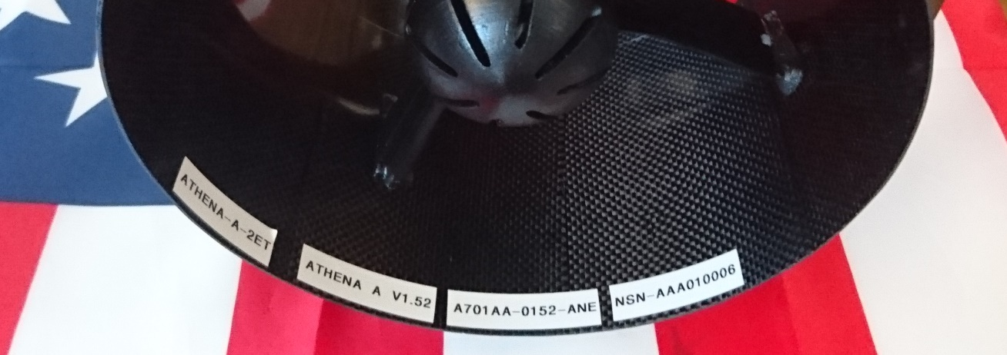



Figure 6 : set of references

Each turbofan has a set of references on the interior bottom edge of the shroud (fig.6) :

* + - Product name and version, in fig.6 “ATHENA-A-2ET-V1.52”
    - Part number, in fig.6 “A701AA-0152-ANE”
    - Serial number, in fig.6 “NSN-AAA010005”

Each Turbofan has external marks (fig.7):

* + - **CE label**: Turbofan meets all the essential requirements of each of the European Directives applicable to it
    - **Not allow to touch or put hand/fingers inside** Warning label the turbofan when running
    - Turbine Suction Warning label: can be felt up to 1 meter / 3.3 feet

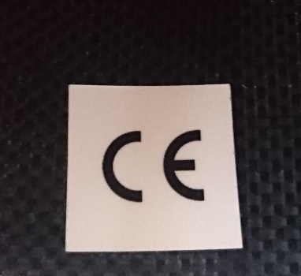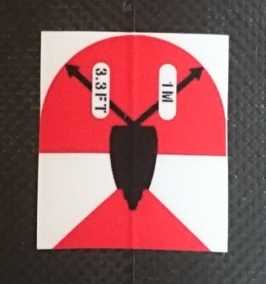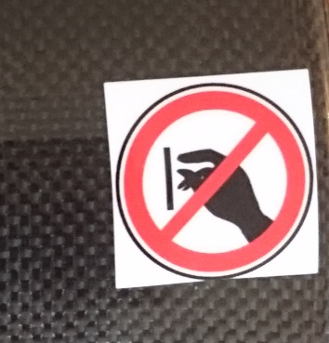

Figure 7 : Standard & Warning Labels

Your turbine can be serviced worldwide in any of our MRO network partners or directly by Neva Aerospace.

All our turbines are followed with an Asset Management Information System in order that we can keep track of the maintenance on your turbine irrespective of where you had the service done.

## Legal Maintenance

Any maintenance not using our original spare parts and/or an accredited MRO by Neva Aerospace will void your warranty.

Any modification to the system is against the Neva Aerospace EUL & TCSG.

Please check the chapter Warranty & Legal for more information.

## Maintenance Schedule:

Maintenance must be done by Neva Aerospace and/or one of Neva’s MRO Network member. Contact us to know the nearest MRO to your location.

|  |  |  |  |  |  |  |  |  |  |  |  |  |  |  |  |  |  |  |  |  |  |  |  |  |  |  |  |  |  |  |  |  |  |
| --- | --- | --- | --- | --- | --- | --- | --- | --- | --- | --- | --- | --- | --- | --- | --- | --- | --- | --- | --- | --- | --- | --- | --- | --- | --- | --- | --- | --- | --- | --- | --- | --- | --- |
| Schedule of maintenance table | | | | | | | | | | | | | | | | | | | | | | | | | | | | | | | | | |
|  |  | |  |  |  | |  |  | |  | |  |  | |  | |  | |  | |  | |  | |  | |  | |  | | | | |
|  |  | |  |  |  | |  |  | |  | |  |  | |  | |  | |  | |  | |  | |  | |  | |  | | | | |
| Time using turbine (hour) --> | | | 500 | 1000 | 1500 | | 2000 | 2500 | | 3000 | | 3500 | 4000 | | 4500 | | 5000 | | 5500 | | 6000 | | 6500 | | 7000 | | 7500 | | **at least on time per year** | | | | |
| Plastic blade  (part number : BLA ….) | | visual check\* |  |  |  | |  |  | |  | |  |  | |  | |  | |  | |  | |  | |  | |  | |  | | | | |
| change | **x** | **x** | **x** | | **x** | **x** | | **x** | | **x** | **x** | | **x** | | **x** | | **x** | | **x** | | **x** | | **x** | | **x** | | **x** | | | | |
| Carbon blade  (part number : BLA ….) | | visual check\* | **x** | **x** |  | | **x** | **x** | |  | | **x** | **x** | |  | | **x** | | **x** | |  | | **x** | | **x** | |  | |  | | | | |
| change |  |  | **x** | |  |  | | **x** | |  |  | | **x** | |  | |  | | **x** | |  | |  | | **x** | | **x** | | | | |
| ESC  (part number : ESC ….) | | visual check\* | **x** |  | **x** | |  | **x** | |  | | **x** |  | | **x** | |  | | **x** | |  | | **x** | |  | | **x** | |  | | | | |
| change |  | **x** |  | | **x** |  | | **x** | |  | **x** | |  | | **x** | |  | | **x** | |  | | **x** | |  | | **x** | | | | |
| Motor  (part number : MOT ….) | | hand check\*\* |  | **x** |  | | **x** |  | | **x** | |  | **x** | |  | | **x** | |  | | **x** | |  | | **x** | |  | |  | | | | |
| change |  |  |  | |  |  | | **x** | |  |  | |  | |  | |  | | **x** | |  | |  | |  | | **x** | | | | |
| Stator + associated support  (part number : STA ….) | | visual check\* |  | **x** |  | | **x** |  | | **x** | |  | **x** | |  | | **x** | |  | | **x** | |  | | **x** | |  | |  | | | | |
| change |  |  |  | |  |  | |  | |  |  | |  | |  | |  | |  | |  | |  | |  | | **x** | | | | |
| Cap  (part number : CAP ….) | | hand check\*\* | **x** | **x** | **x** | | **x** | **x** | | **x** | | **x** | **x** | | **x** | | **x** | | **x** | | **x** | | **x** | | **x** | | **x** | |  | | | | |
| change | ***- must be changed if the cap is able to move in the arm -*** | | | | | | | | | | | | | | | | | | | | | | | | | | **x** | | | | |
| screw, washer and nuts | |  | ***- must be changed each time it is unmounted -*** | | | | | | | | | | | | | | | | | | | | | | | | | | **x** | | | | |
|  | |  |  | | |  | | |  | |  | | |  | |  | |  | |  | |  | |  | |  | |  | |  |  |  |  |
| \* Visual check : | | no visible crack, fissure, rift or split for parts, no lampblack or capacitor distortion for ESC | | | | | | | | | | | | | |  | |  | |  | |  | |  | |  | |  | |  |  |  |  |
| \*\* Hand check : | | no possible movement for the cap, smooth move for motors | | | | | | | | |  | | |  | |  | |  | |  | |  | |  | |  | |  | |  |  |  |  |

Maintenance is to be done within Neva Aerospace Maintenance, Repair and Overhaul (MRO) approved network.

### Turbine Inspection – Max Flight Time without checks – 30HRS:

INSPECTION OF TURBINE by EYES AND HANDS MUST BE DONE EVERY **30 HRS**

You must stop your flights and check all parts thoroughly of your turbine – unplugged and disarmed:

Search for cracks, deformation or other damage

**Visual and Hand check:**

- All blades

-inner shroud

-outer shroud

-caps

-arms /stages (stators)

-plugs & cables

-Concentricity screws

-(1.65 plastic): Connection screws

**After you reconnect / re-arm turbine:**

Noise & vibration checks from 0 to 100% of power while securely attached to the ground (run-up)

### Concentricity Screws:

It is strictly prohibited to touch or try to adjust the concentricity screws.



**Any attempt to tamper with concentricity screws may lead to complete turbine destruction!**

You can easily see the concentricity screws of your turbine as they are protected with a RED or ORANGE varnish.

ONLY A TRAINED OPERATOR CERTIFIED BY NEVA AEROSPACE CAN ADJUST THE CONCENTRICITY SCREWS.

Photos:

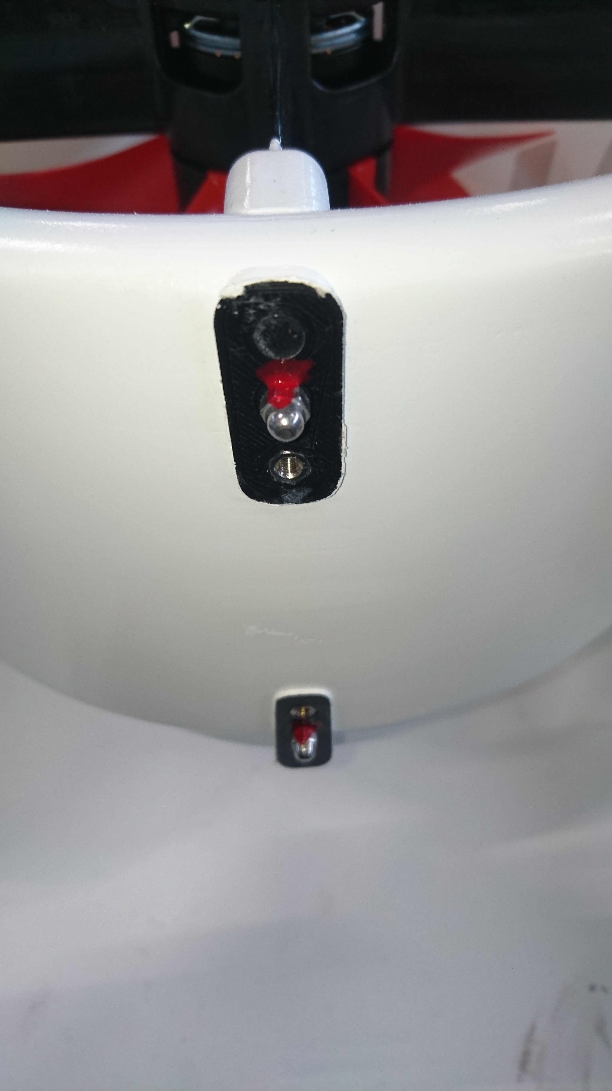

Each 2 stage contra-rotating turbine has 8 concentricity screws which are used to hold the stages and adjust concentricity.

On this photo we see 2 screws - one for the inlet and one for the outlet. There are 2 screws on each quarter of the turbine, totalling 8 concentricity screws.

The concentricity screws are marked in factory after bench testing and/or flight testing with a red varnish.

NEVER try to adjust any of these concentricity screws. It could lead to full destruction of your turbine.



In the case you detect a concentricity screw may have moved or unscrewed during an inspection:

STOP ALL OPERATIONS AND DO NOT ATEMPT TO FLY

CONTACT IMMEDIATELY Neva’s support or Neva’s MRO.

### Athena-A-2ET-V1.65: (plastic composite)

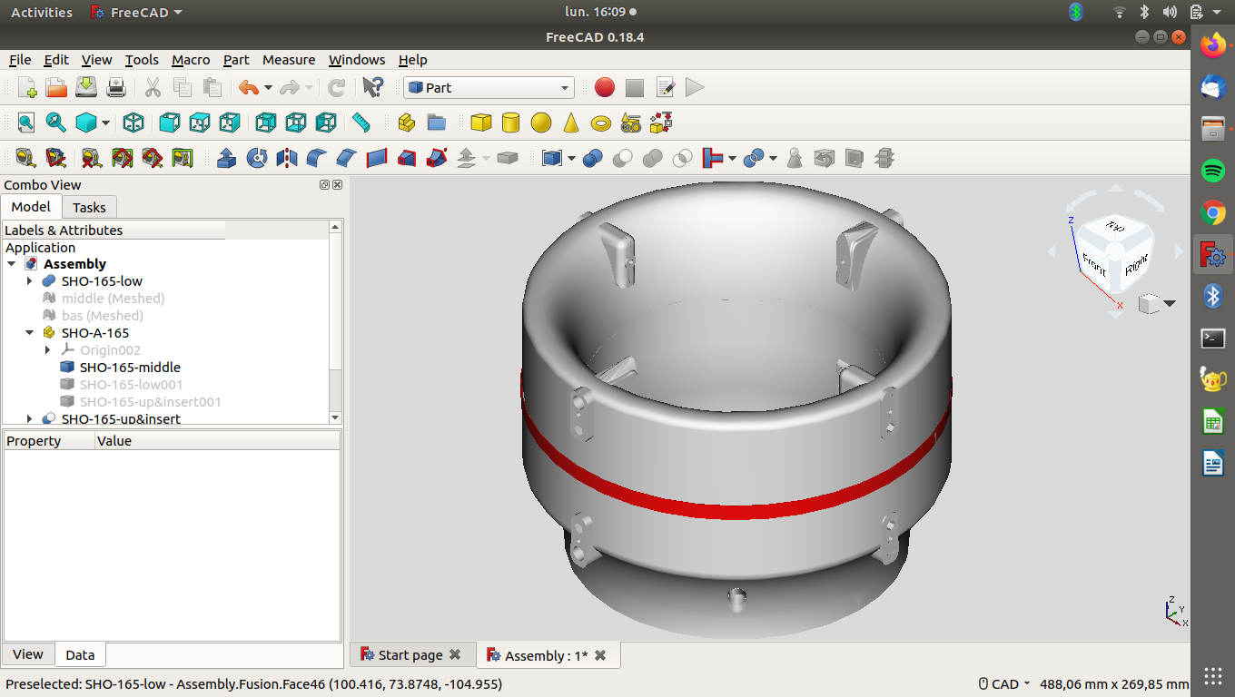

The V1.65 plastic shroud is made of 3 parts :

Inlet Shroud

Outlet Shroud

Junction ring

The Inlet Shroud and Outlet Shroud are screwed together with 4 M3 screws – **The connection screws**

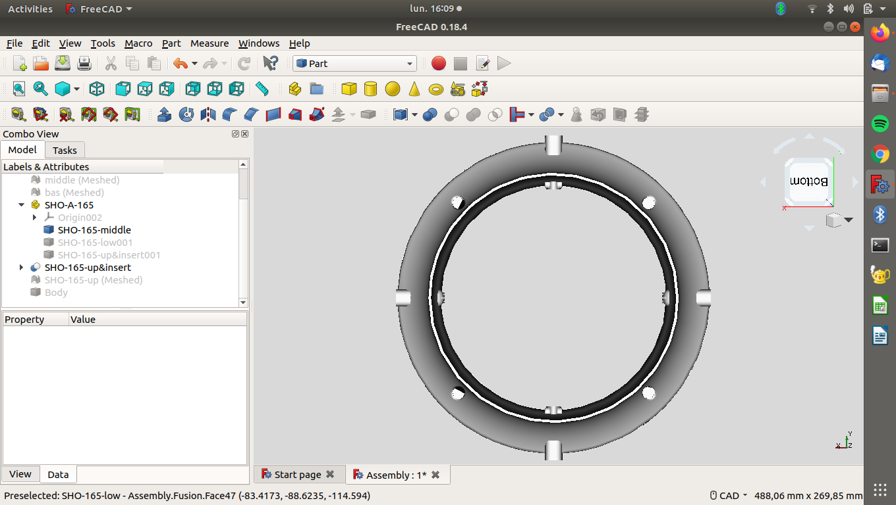



**Before flying, check the junction ring. If the junction ring is distorted you must not fly. Send the fan for maintenance.**

**NEVER try to adjust any of these connection screws. It could lead to full destruction of your fan. Any tempering will void the warranty. In case you notice a change or loosening DO NOT FLY and SEND your fan to service**

### Pressure Equalisation

The body of the shroud of the turbine has been designed to ensure pressure equalisation when flying with micro-holes within the connection-plugs of the turbine shroud so that the inside of the turbine equalize with the outside pressure when flying.

Note: On some turbines you may find micro-holes near the plugs and on the bottom for condensation release. It is perfectly normal. These are not cracks. They are 1mm diameter and may not been seen easily by eyes.

### Turbine Shroud Warranty

If (i) the inspection is done regularly, (ii) the maintenance schedule is respected, (iii) the maintenance is done through Neva MRO’s network, and (iv) there has been no accident or mechanical stress other than standard flight, the body parts of your turbine have the following warranty time from date of reception:

* **Carbon composite shroud body : 3 Years or 5,000 Hrs of flight**
* **Plastic composite shroud body: 1 Years or 2,000 Hrs of flight**

In case of defect we provide part exchange. Contact us or your regional MRO :

[support@neva-aero.com](mailto:support@neva-aero.com)

### Table of Spare Parts

|  |  |  |
| --- | --- | --- |
| Quantity | Part Number | Nomenclature |
| 2 | ISY1A002 | Stator support |
| 1 | SHO3A002 | Shroud |
| 2 | ISN1A001 | Stator support |
| 2 | OSY1A001 | Stator support |
| 1 | OSN1A002 | Stator support |
| 1 | OSY1A003 | Stator support |
| 2 | OSY2A001 | Stator support |
| 1 | OSY2A003 | Stator support |
| 1 | OSN2A002 | Stator support |
| 2 | ISN2A001 | Stator support |
| 2 | ISY2A002 | Stator support |
| 2 | STA3A002 | Stator |
| 2 | MOT3A001 | BLDC-4S-Athena-A-2ET-V1.x |
| 1 | HUB1A001 | Hub |
| 5 | BLA1A001 | Blade |
| 2 | CAP3A001 | Cap |
| 2 | WASZZ004 | Washer M6 – Nylon |
| 16 | NUTZZ001 | M3 Nylon Washer |
| 8 | SCRZZ005 | Screw M3x10 Steel |
| 2 | NUTZZ002 | Nut M6 – Nylstop |
| 1 | HUB2A001 | Outlet Hub |
| 5 | BLA2A001 | Blade |
| 8 | WASZZ001 | Washer M3 |
| 4 | SCRZZ006 | Allen Screw M3x50, black |
| 4 | SCRZZ001 | Allen Screw M3x45, black |
| 2 | ESC3A001 | ESC-QP-25-NVA |

**Not respecting the maintenance schedule will null and void the warranty.**

## Electronic Speed Controller for the Motor(s)

**BESPOKE ESC manufactured by Castle Creations Inc. (USA) on behalf of Neva Aerospace.**

**Standard ESC from Castle Creations Inc. are not approved for maintenance and retrofit.**

**Neva Aerospace turbines use a specific custom firmware.**

**Retrofitting any commercial ESC may damage your turbine or downgrade performance or lead to full turbine destruction.**

REFERENCE : **Neva-ESC3A001**

*Note: Using another ESC will void your warranty and may destroy your turbine.*

**Our ESC are NOBEC ONLY :**

|  |  |  |  |
| --- | --- | --- | --- |
| **Technical Specs** | | | |
| SPECIFICATIONS | MINIMUM | TYPICAL | MAXIMUM |
| Operating Input voltage | 6.0V |  | 25.2V |
| BEC Input Current @ 12V, 100,000 eRPM (no BEC)1 |  | 58.2 mA |  |
| Current @ 5mph (8km/h) airflow3 |  |  | 35.0A |
| Current @ 40mph (64 km/h) airflow3 |  |  | 50.0A |
| PWM Switching Frequency (kHz) |  | 8-16, Dynamic |  |
| Characteristics at 25°C (77°F) unless stated otherwise.  1Specification only applies to the Multi-Rotor 35 “NO BEC” units. “NO BEC” units require a BEC supply voltage in order to operate.  3Current is specified as the maximum value the ESC can handle at full throttle for the duration of a single 4,000 mAh battery pack with the ESC in the specified speed of 25°C (77°F) or cooler airflow. Controller temperature must never exceed 100°C (212°F). Exceeding current or temperature ratings may damage components and may shorten the life of the ESC. Always verify system current draw at full-throttle. Decrease load or increase airflow to decrease the ESC’s operating temperature. | | | |
| Dimensions | Width: 0.88" (22.4mm) Length: 1.93" (49mm) Depth: 0.33" (8.4mm) | | |
| Weight with wires (no BEC) | 0.854 oz. (24.2g) | | |
| Weight without wires (no BEC) | 0.427 oz (12.1g) | | |
| Items needed for operation or installation | Battery connector and motor connectors sold separately | | |
| Programmability | **No programming authorized.** | | |

|  |
| --- |
|  |

*NO ESC FIRMWARE UPGRADE. Neva restricts any firmware upgrade to ensure safety and security and warranty on its product. Using the commercial updater will either fail or will lead to damaging your turbine.*

**Information from Castle Creations Inc.**

Source – Courtesy of Castle Creations Inc. USA : www.castlecreations.com Castle Multi-Rotor Series User Guide

### INTRODUCTION

This manual provides instructions on incorporating your Castle Creations Multi-Rotor ESCs into your aircraft, from wiring and mounting your ESCs to configuring them for your first flight. For more information on the technical aspects of your ESCs, please see the applicable Multi-Rotor Technical Datasheet.

### IMPORTANT WARNINGS

• *Castle Creations is not responsible for your use of this product or for any damage or injuries you may cause or sustain as a result of its usage.*

*• Castle controllers are for use by adults only.*

*• Always remove all propellers when working on a power system with the battery connected.*

*• Please observe all local and federal laws regarding the flying of remote control aircraft.*

*• Never fly over others or near crowds.*

*• An RC vehicle crash or a power system malfunction may result in fire. Never operate RC vehicles in a flammable environment, such as around dry vegetation.*

*• Castle Multi-Rotor ESCs come programmed with default settings optimized for Multi-Rotors using direct drive outrunner motors. Using the Multi-Rotor settings in applications other than Multi-Rotor platforms can be potentially harmful to the ESC.*

*• Low voltage cutoff is DISABLED by default on all Multi-Rotor controllers. You must use an external device to monitor battery voltage or manually enable low voltage cutoff to avoid damage to your batteries.*

*• The “No BEC” versions of Multi-Rotor ESCs require the red wire of the receiver lead to be connected to a 4.5-8.0 V source. The red wire of the receiver lead should remain intact and connected to the flight-controller/receiver power circuit.*

*• Do not drive a motor with Multi-Rotor ESCs powered by a DC power supply without first disabling Active Braking and Idle Brake. Voltage spikes from sudden braking may cause damage to the supply and ESC.* Multi-Rotor User Guide

### CONNECT THE ESCS TO YOUR FLIGHT CONTROLLER

Connect the ESC receiver leads to the corresponding throttle channels on your flight-controller.

*Note that the Multi-Rotor ESC are NO BEC, an external power supply may be used.*

### FIRST-FLIGHT SETUP

**SEE CHAPTER 9 §a)**

### OPERATION

**SEE CHAPTERs 9 §b) and 10 §a)**

### PROGRAMMABLE FEATURES

IT IS FORBIDEN TO CHANGE PROGRAM OF THE ESC

ESC ARE CONFIGURATED BY NEVA AEROSPACE

IF ANY CHANGE **Warranty will be VOID**

### ESC OPERATIONAL TONES AND ERROR CODES

In the event of a pullback or shutdown the ESC will produce an error code for trouble shooting. The ESC uses the motor to produce beep codes. The red LED will also blink out the error codes. Refer to the table below for error code meanings.

A dot (•) stands for a short beep and a dash (–) stands for a long beep.

|  |  |  |
| --- | --- | --- |
| **Tone** | **Meaning** | **Description** |
| **•** | ESC ready to run motor | ESC beeps motor every 20 seconds to remind user that power is connected to the ESC. This notice may be disabled in Castle Link. |
| **• •** | Start Fail | ESC was unable to start the motor. |
| **• -** | Low Voltage Cutoff | Main battery voltage dropped below the cutoff value (disabled by default). |
| **• • •** | Propeller Strike/ Motor Anomaly/ Motor Desync Detected | ESC detected a sudden mechanical interruption of the motor’s rotation. |
| **• • -** | Radio Glitch | ESC detected unusual signals or loss of signal on receiver lead. |
| **• - •** | Over-Temperature | ESC reached an over-temperature condition when operated under too high a load, operated without proper cooling airflow. |

##### R&D Settings

If you need specific settings – such as bench control potentiometer – ie non-controller driven ESC. We can provide dedicated settings for bench tests if need be.

Contact our support:

[Support@neva-aero.com](mailto:Support@neva-aero.com)

# Warranty & Legal

## Legal Maintenance

Any maintenance not using our original spare parts and/or an accredited MRO by Neva Aerospace will void your warranty.

Any modification to the system is regulated by the Neva Aerospace End Use Licence (EUL).

## Warranty Time:

Your warranty applies if a Neva Aerospace End User Licence (EUL) is in force between you, the original owner and Neva Aerospace, and/or a maintenance contract with Neva Aerospace or once of its certified MRO. The EUL is granted automatically when your purchase our equipment – while signing our TCSG and/or or quotation or purchase order.

Your warranty starts up on reception of your turbine (delivery bill date) and the parts are guaranteed for the above duration 12 months or wear-time – whichever is first- see the Maintenance Schedule.

The shroud (or body) of the turbine has a specific life-time warranty of its own – see the chapter Turbine Shroud Warranty.

## Timing the warranty and wear parts:

In the case the ESC has no tachometer make sure you provide log of your flights so we can follow the aging of your equipment system.

Some turbines may have a Hobb Timer – tachometer- recording the time of use of your ESCs (and so motor and turbine). Please see the chapter on ESC or check with our support: [support@neva-aero.com](mailto:support@neva-aero.com) .

## Legal in case of reselling and second-hand equipment:

To ensure that the technology is used according to the law and provide warranty and parts, we register the owners of all our equipment. Your information is kept confidential and are used only in case of insurance claims or police or air police request or governmental warrants -under EU, UK, or US laws.

### Resell Process:

Due to the potential of dual use of the technology, Neva Aerospace enforces a strict control on the EUL and ownership transfer to ensure that the technology stays within US, EU and UK agreed countries – i.e. non-embargo countries or companies.

The new owner must sign the End User Licence (EUL) of Neva Aerospace, as did the Original Owner.

### Process for Transfer of Ownership:

Step 1 - Before you resell you need to ensure that the new user has signed a Neva EUL – please contact [sales@neva-aero.com](mailto:sales@neva-aero.com) with the New Owner contacts to ensure a new EUL is signed by the new user and do wait for the acknowledgement of EUL signed from Neva Aerospace team.

Step 2 – Neva Aerospace sill send you and the New Owner an acknowledgement of EUL agreement signed between Neva Aerospace and the New Owner. Wait for this in order to enact to the sale documents.

Step 2- Once the transfer of ownership is enacted you must notify: [sales@neva-aero.com](mailto:sales@neva-aero.com) ‘turbine change of ownership’ with the new owner details and the model and serial numbers of the turbines sold.

Step-3 You and the New Owner will then receive an acknowledgement of transfer of ownership and that the serial numbers have now been registered in our database to the new owner and the warranty transfer is now on the name of the new owner.

### Failing to respect this procedure can lead to the following:

1. It could leave you, the original owner, as potentially responsible of a wrongdoing according to export law and in breach of Neva Aerospace EUL.
2. You as the original owner could be found liable to have provided technology to a non-authorised country or organisation. – either by your local laws of exportation or by Neva Aerospace EUL.
3. The New Owner will not have any warranty as our warranty and spare parts delivery is subject to agreeing with Neva EUL.
4. In the event Neva Aerospace would suffer due to the non-respect of this procedure, it reserves the right to seek legal action against the Original Owner.

In substance you are fully responsible to whom you sell an equipment which may be use for dual use.

### Purchase of Second Hand Neva’s Equipment:

1. If you intend to purchase second-hand equipment, we will of course run a check with the previous owner to ensure the turbines are not stolen and that the owner is duly registered with a proper warranty.
2. You can contact Neva Aerospace to check if Neva Aerospace or its network of Distributor & Agents have genuine second-hand equipment available: [sales@neva-aero.com](mailto:sales@neva-aero.com) .

### Legal on Turbine reselling & ownership:

1. In order to ensure that the technology is used according to the law and by rightful owner, Neva reserves the right to lock turbines -either physically or by mean of software- in the case the equipment is reported stolen, is under a governmental warrant, or a new owner has failed to sign the EUL, and/or the owner is unknown, and/or if a resell procedure for any equipment has been not followed and the documentary of EUL not properly in place,
2. Neva Aerospace will bear no cost nor any damage to third parties due to situation where a turbine cannot be in use due to the above chapters,
3. Registering as a new Owner is important for updates, upgrade, maintenance service schedule, accessing spare parts and retrieving your turbines in case of theft,
4. If you have any doubt about the turbine you own or intend to purchase you can contact us with your turbine(s) serial numbers and we will be able to assist you.

### Stolen or Lost Equipment:

If your equipment has been stolen or lost, contact us immediately on [sales@neva-aero.com](mailto:sales@neva-aero.com) :

Subject “Theft report” / “Lost Report”– with your model and serial numbers and we will let you know if have heard of it or if we are aware of deal on the second-hand market.

# Legal disclaimer

1. The equipment: Electric Turbofan (ETF) from Neva Aerospace (‘the seller’, or the manufacturer’) is purchased by the buyer (ie “the Original Owner’).
2. THE EQUIPMENT AND EACH PART THEREOF IS BEING SOLD “AS IS” UNDER NEVA AEROSPACE SPECIFICATIONS AND GENERAL CONDITIONS OF SALES, WITHOUT ANY REPRESENTATION, WARRANTY OR GUARANTEE OF ANY KIND BEING MADE OR GIVEN BY NEVA AEROSPACE, ITS SERVANTS OR AGENTS, EXPRESS OR IMPLIED, ARISING BY LAW OR OTHERWISE OUTSIDE OF NEVA AEROSPACE SPECIFICATIONS AND WARRANTIES.
3. NEVA AEROSPACE SPECIFICALLY DISCLAIMS: (A) ANY EXPRESS OR IMPLIED WARRANTY AS TO THE AIRWORTHINESS, VALUE, DESIGN, QUALITY, MANUFACTURE, OPERATION, OR CONDITION OF THE EQUIPMENT; AND (B) ANY EXPRESS OR IMPLIED REPRESENTATION OR WARRANTY OF MERCHANTABILITY OR FITNESS FOR USE OR FOR A PARTICULAR PURPOSE; AND (C) ANY IMPLIED REPRESENTATION OR WARRANTY ARISING FROM COURSE OF PERFORMANCE, COURSE OF DEALING OR USAGE OF TRADE.
4. **Warranty will be void** if one or several of the following would happen:
   1. Your turbine has been part of a mechanical stress – such as but not limited to, hard landing, belly landing, crash landing, collision, etc…; and/or
   2. You would exchange, replace or maintain parts without using Neva Aerospace parts; and/or
   3. You would have added or remove parts from the original delivered turbine; and/or
   4. You would do any kind of modification to the ESC, motor, or other electrical systems and/or mechanical systems; and/or
   5. You would not follow maintenance procedures or would not ensure maintenance through Neva Aerospace or its Maintenance Repair Overhaul (MRO) network of approved MRO service; and/or
   6. You would be flying outside of the limitation permitted by Neva Aerospace specification; and/or
   7. You would be flying outside of the regulations of the flying area; and/or
   8. You would be flying without proper licence and/or authorisation; and/or
   9. Your aircraft would not have passed local regulations certification and/or obtained air worthiness certification, and/or
   10. If it is a stolen equipment or ownership transfer has not been declared, and/or
   11. Your organisation has not a valid End Use Licence(EUL) from Neva Aerospace.
5. *Read the chapter 4 – Warranty & Limitations.*
6. Neva Aerospace makes no warranty or representation regarding the airworthiness or certification nor the intend use. You use Neva Aerospace equipment fully at your own risks and Neva Aerospace decline any responsibility from using its equipment and/or the legality of using its equipment within the intended airspace.

# ANNEXES

## Neva End User Licence





If you need a military activity licence, please contact us with your credentials. – [sales@neva-aero.com](mailto:sales@neva-aero.com)